**Lung Water Level Analysis using MATLAB**

**OBJECTIVE:**

* This project aims to develop an automated lung water level detection system using MATLAB.
* By analyzing X-ray images, the system can identify fluid accumulation, calculate water levels, and compare them with a threshold to determine if the patient is affected.

**Tools & Technologies Used**

* + **Software:** MATLAB R2024b
  + **Techniques:** Image Processing, Segmentation, Thresholding

### ****Workflow or Methodology****

* 1. Image Acquisition
  2. Preprocessing (Grayscale, Filtering)
  3. Segmentation
  4. Fluid Detection and Percentage Estimation
  5. Output Visualization

**CODE:**

clc; clear; close all;

% Load X-ray image (Replace 'lung_xray.jpg' with actual image)

img = imread('C:\RUPIKA_ECE_C\lungs1.jpeg');

img = imresize(img, [256, 256]); % Resize for uniform processing

% Convert to grayscale

gray_img = rgb2gray(img);

% Apply Gaussian filter to remove noise

filtered_img = imgaussfilt(gray_img, 1);

% Enhance contrast using adaptive histogram equalization

enhanced_img = adapthisteq(filtered_img);

% Display images

subplot(2,3,1); imshow(img); title('Original X-ray');

subplot(2,3,2); imshow(gray_img); title('Grayscale');

subplot(2,3,3); imshow(enhanced_img); title('Enhanced Image');

% Apply Edge Detection (Canny Method)

edges = edge(enhanced_img, 'canny');

% Apply Otsu’s Thresholding for segmentation

threshold_level = graythresh(enhanced_img);

binary_img = imbinarize(enhanced_img, threshold_level);

% Morphological operations to remove noise

cleaned_img = imopen(binary_img, strel('disk', 3));

% Display segmentation results

subplot(2,3,4); imshow(edges); title('Edge Detection');

subplot(2,3,5); imshow(binary_img); title('Thresholded Image');

subplot(2,3,6); imshow(cleaned_img); title('Cleaned Binary Image');

% Label connected components in the binary image

stats = regionprops(cleaned_img, 'Area', 'BoundingBox');

% Calculate the total lung area

total_area = numel(cleaned_img);

% Calculate the fluid-affected area

fluid_area = sum([stats.Area]);

% Calculate fluid level percentage

fluid_percentage = (fluid_area / total_area) * 100;

fprintf('Detected Fluid Level in Lungs: %.2f%%\n', fluid_percentage);

% Define threshold for lung water level (Adjust based on medical data)

fluid_threshold = 20; % Above 20% is considered high

% Classify patient condition

if fluid_percentage > fluid_threshold

disp('WARNING: High Water Level Detected! Patient is Affected.');

else

disp(' Normal Condition: No Excess Water Detected.');

end

**How to Run the Code:**

1. Open MATLAB
2. Load the .m file
3. Run the script and choose an X-ray image
4. View results in Command Window

**SAMPLE INPUT:**

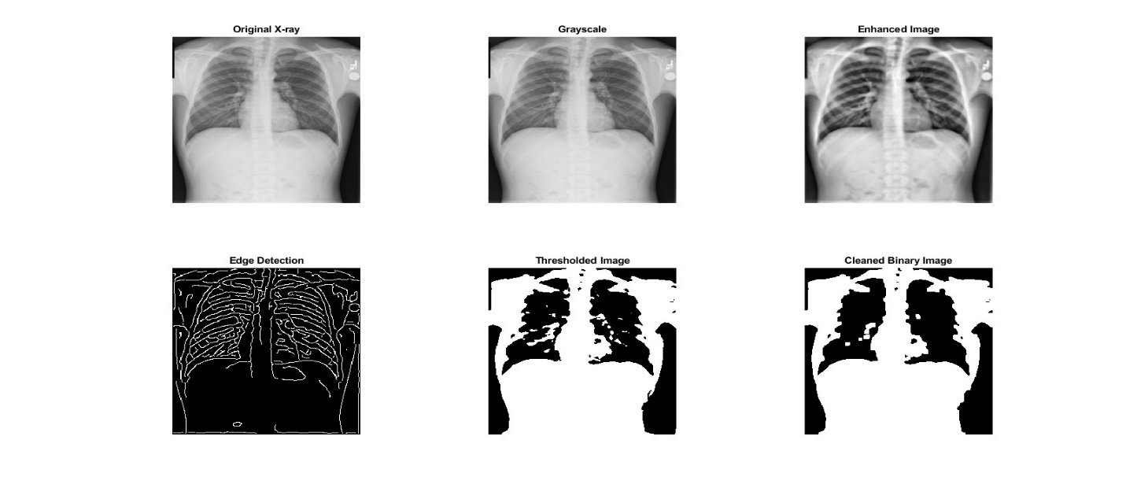

**OUTPUT:**

